Module:-COSA(Concept Of Operating System And Administration) Date:- 31/10/2022
Assignment :- 05 Name:- Prauthviraj Nikam

Configure CUP’s
Step-1:- Install CUP’s
CMD:-
dnf install cups
systemctl status cups
systemctl start cups
systemctl enable cups
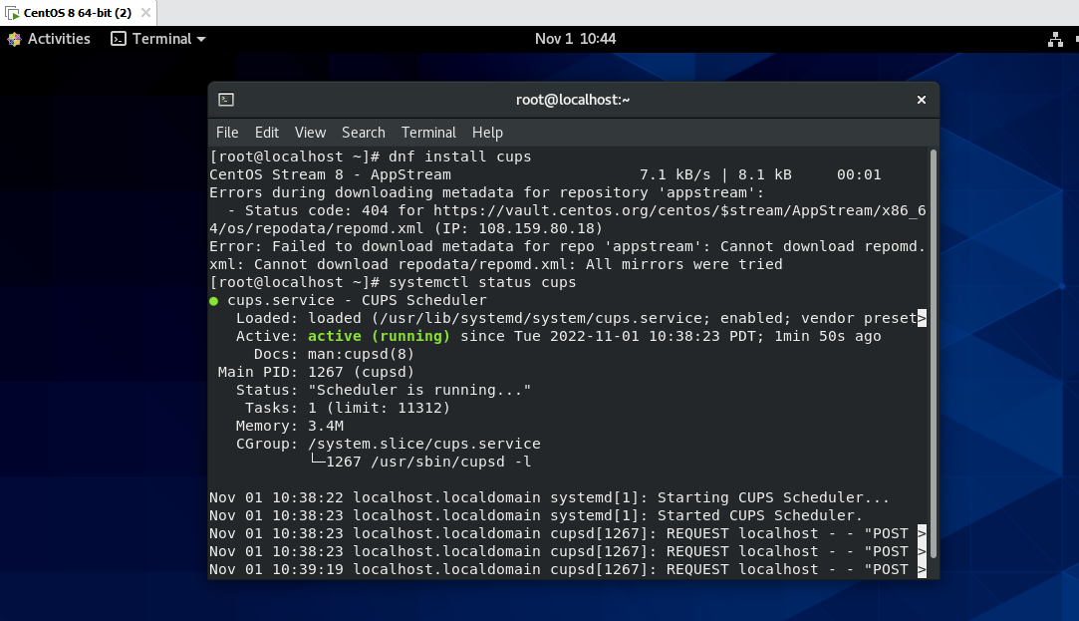

Step-2:- Configure cups
CMD:-
vim /etc/cups/cupsd.conf
#Listen local host :631
Listen Port 631
On Browsing
Browsing On
Restrict Access to the server
ALLOW @LOCAL
Restrict Access to the admin
ALLOW @LOCAL

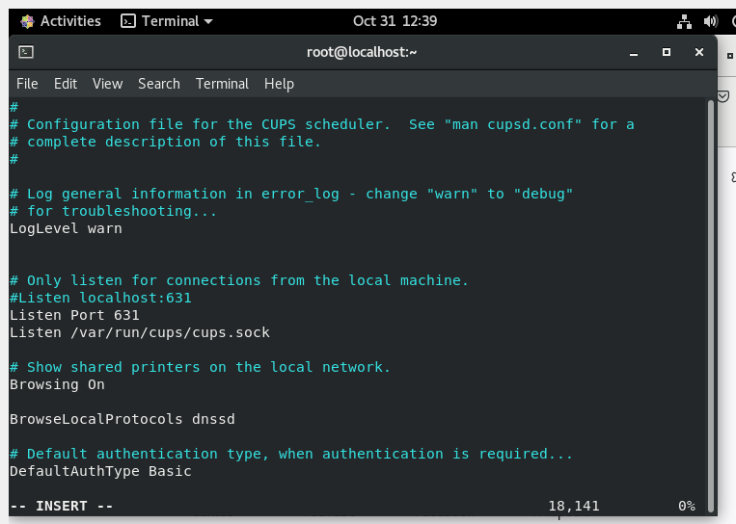

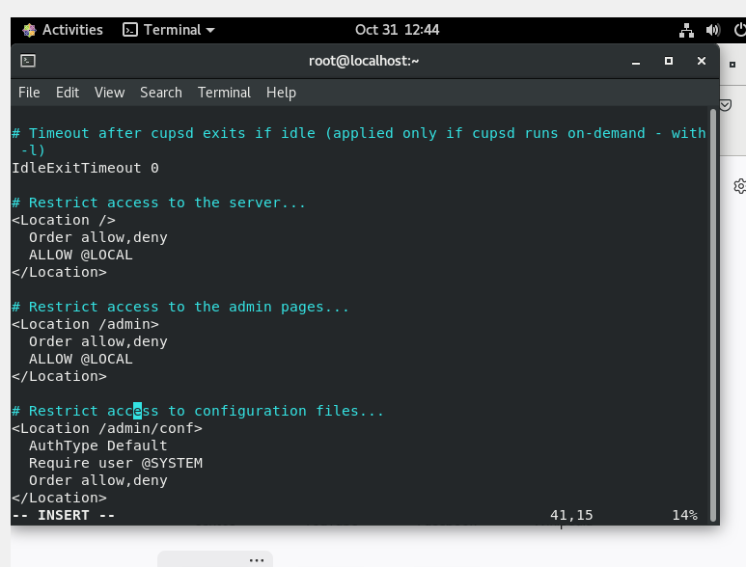
Step-3:- After Configuration Restart the cups Service
